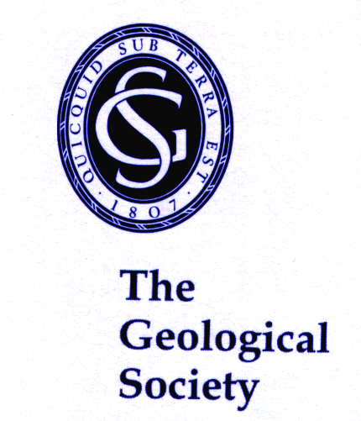
From a Geology Degree to a Career in Teaching
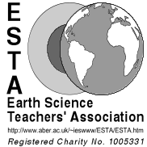

A teaching career in the schools of today provides the challenge and opportunity

of interacting with young people. The profession provides a range of job opportunities, good promotion prospects, a reasonable salary system and clear career structures.

Teacher Education

There are several ways in which you could use your degree in Geology, Geoscience or Earth Science, as the basis of a teaching career in schools. These involve taking a Post/Professional Graduate Certificate in Education (PGCE) at a Teacher Training Institution, a School Centred Initial Teacher Training (SCITT) programme, a Graduate Teacher programme (GTP) or the ‘Teachfirst’ programme. Proposed government policy is currently seeking to develop additional routes into teaching.
Geology is taught at A-level and/or GCSE at around 300 centres in England and Wales, including state schools, independent schools and sixth form colleges. Since it is usually impossible to fill a timetable with geology teaching, geology teachers also teach other subjects. As Earth science forms a small part of the National Science Curriculum and the National Geography Curriculum in England, Wales and Northern Ireland, most geology teachers also teach in one of those areas.
All the current Higher Education Institution (HEI)-based (PGCE) and SCITT routes below require the payment of tuition fees, but student loans are normally available for home and European Union students. The options for teaching are as follows:

- Primary school teaching - by taking a PGCE in Primary Education, courses are provided by many Teacher Education institutions in the UK.
- Secondary school Science teaching - by taking a PGCE in Secondary Education, specialising in one of the main Science specialisms; these courses are provided at many teacher education institutions in the UK. Most require two Science subjects at 'A' level or their equivalent. All school Science courses include an element of Earth Science. Once in school, teachers can teach any subject that the school will allow them/require them to, so there may be opportunities for teaching GCSE or AS/ A2 level Geology. Tuition fees are determined by individual institutions and range up to £9000. Proposed bursaries range from £0 to £20,000 depending upon degree grade (1st, 2.1 or 2.2).
- Secondary school Geology/Science teaching - by taking a one-year PGCE in Secondary science education, with Geology as a specialism. This specialist course is currently provided by only one institution in the UK, Keele University. The course covers the teaching of Geology at GCSE and AS/ A2 levels as well as broad balanced Science teaching. The course requires two Science subjects at 'A' level or their equivalent. Fees are as above; bursaries range from £0 to £9000 depending on degree grade.
- Secondary school Science teaching, but you do not have two Science subjects at 'A' level or their equivalent - apply for a Chemistry/ Physics Subject Knowledge Enhancement (SKE) course which provides academic teaching in Chemistry/ Physics and other areas of science; most courses are 36-weeks long. Passing the SKE course enables progression to a 1-year PGCE or SCITT course or a GTP providing a specialism in Chemistry or Physics.
- In 2011/12 a £7,200 training bursary was available for 36-week SKE courses and no fees were payable; the bursary/fee structure for future SKE courses has still to be announced. Funding for the succeeding course in Chemistry/Physics will range from £12,000 to £20,000 (2012-13 figures) and tuition fee levels up to £9000 will be set by individual institutions. Once in school, teachers can teach any subject that the school will allow them to/require them to, so there may be opportunities for teaching GCSE or AS/ A2 level Geology at a later date.
- Secondary school Geography teaching - by taking a PGCE in Secondary Education, specialising in Geography, provided at many Teacher Education institutions in the UK. Most courses require that at least half your degree is in Geography. Fees are as above and bursaries from £0 to £9000 will be available to geography students, depending upon degree grade.
- Teaching through the SCITT programme - involves training in school with most training taking place in the ‘lead’ school.
- Teaching through the GTP programme - involves training in schools whilst undertaking a paid teaching role. This route is aimed at people wanting to change their careers rather than those coming direct from University. In funded places, training fees do not have to be paid.
- Secondary school teaching through the ‘Teachfirst’ route - involves a two year commitment to the programme and teaching in a challenging school in one of the designated regions of England. It begins with a six-week summer school and continues in one school with additional input provided by a teacher education institution. This route gives a PGCE at the end of the course. You receive a full teacher’s salary, paid by the school. To teach science, you need a 2.1 in a science subject and two science A-levels.

Many of the PGCE routes described above are not able to provide school placements
where Geology teaching experience is possible.
Further information on all these courses is available by contacting the institutions concerned;
most institutions provide course details on the internet.
All applications for PGCE courses in England, Wales and Northern Ireland are made through the Graduate Teacher Training Registry (GTTR), http://www.gttr.ac.uk/, and in Scotland are through ‘Teach in Scotland’ http://www.teachinginscotland.com/.
Details of funding eligibility and levels of fees are available from the Training and Development Agency for Schools (TDA) website at: http://www.tda.gov.uk/, from Student Finance England at: http://www.studentfinance.direct.gov.uk/ and from the DirectGov website (http://www.direct.gov.uk/) for students from other UK countries.

